

**User Guide**

**Order Tracking**

Prepared by: Edgar Wells Andromeda Trading Ltd

Date:

Version:

INDEX

INDEX 2

1 Revision Control 3

1.1 Document Approval 3

2 Introduction 4

2.1 Purpose 4

2.2 Scope 4

2.3 Definitions and Abbreviations 4

2.4 References 4

2.5 Overview 4

2.6 Contact Details 4

3 GPS Tracking Devices 5

3.1 The GPS tracking devices 5

3.2 Charging 5

3.3 Switching the device on 5

3.4 Normal operation 5

3.5 Turning the device off 6

3.6 Carry the device 6

4 Rameses 7

4.1 Assigning trackers to drivers 7

4.2 Adding a tracker with a driver float 8

4.3 Adding tracker to a driver without a float 9

4.4 Remove a tracker from a driver 10

5 The GPS map application 11

5.1.1 The map key 11

5.1.2 The Status Bar 12

5.1.3 The Menu 12

5.1.4 Drivers Button 12

5.1.5 Orders Button 13

5.1.6 Auto Zoom Toggle Button 14

5.1.7 Default Zoom Button 15

5.1.8 Zoom To Driver Button 15

5.1.9 Zoom To Order Button 16

5.1.10 Controlling the map 17

6 Using GPS tracking 18

6.1 Driver start 18

6.2 New order 18

6.3 Order status changes 19

6.4 Dispatching an order 19

6.5 Proximity delivery 20

6.6 Cashing off an order 20

6.7 Driver finish 21

7 Troubleshooting and useful information 22

7.1 GPS Tracking Map 22

7.2 GPS tracking devices 22

7.3 Rameses 23

# Revision Control

| **Revision** | **Description of Changes** | **Revised By** | **Signed Off** | **Date** |
| --- | --- | --- | --- | --- |
| 1.0 | Initial Document | Edgar Wells | No |  |
| 1.1 | Converted from GPS Tracking to Order Tracking | Rob Dunn | No | 08 Feb 2010 |
|  |  |  |  |  |

## Document Approval

|  |  |  |  |
| --- | --- | --- | --- |
| **Signatory** | **Designation** | **Signature** | **Date** |
| Ben Cole | CIO |  |  |
| Ben Portsmouth | CEO |  |  |

# Introduction

## Purpose

The purpose of this documentation is to guide users through Order Tracking and to be used for training purposes for clients

The following details that will be included in this document:

* Process flows for the system
* Explanation of processes
* Screen Explanations
  + Detailing each field
  + Detailing buttons/commands that can be run from screen
  + Definitions of Data Headings

## Scope

This document will cover the available Order Tracking functionality in version X.X.

## Definitions and Abbreviations

|  |  |
| --- | --- |
| **Abbreviation** | **Description** |
| Order Tracking |  |
| Rameses | Andromeda’s POS system |
|  |  |

|  |  |
| --- | --- |
| **Concept** | **Definition** |
|  |  |
|  |  |
|  |  |
|  |  |
|  |  |
|  |  |
|  |  |

## References

|  |  |  |
| --- | --- | --- |
| **Document Name** | **Version** | **Date** |
|  |  |  |
|  |  |  |

## Overview

This document is designed to be used for user reference and training

## Contact Details

For further information please contact Andromeda Trading Ltd on

+44 (0)870 118 8010

or visit

<http://www.androtech.com>

# GPS Tracking Devices

## The GPS tracking devices

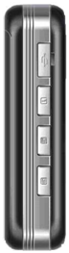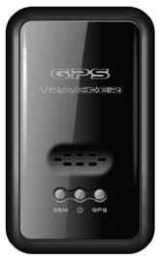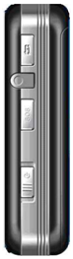

Charger socket

Power button

Red light - GSM (mobile phone) indicator

Blue light - GPS indicator

Yellow light - power indicator

## Charging

When the GPS tracking device is plugged in to a charger, a red light will appear on the charger to indicate that the attached device is being charged. The red light on the charger goes out when the device is fully charged. The power indicator light on the GPS device also indicates that it is charging:

|  |  |
| --- | --- |
| **Power indicator light (yellow)** | **Meaning** |
| Off | Power is off or charging is complete |
| Flashing | Charging |

## Switching the device on

Slide the power button (on the side of the device) to one side. All three lights on the front of the device will illuminate. The device will then start searching for a GSM mobile phone network and attempt to get a GPS fix.

The device has to get the “first fix” from the GPS satellites which can take a few minutes. To speed this up give the unit a clear view of the sky.

## Normal operation

|  |  |
| --- | --- |
| **Yellow light (power)** | **Meaning** |
| Off | Power is off or charging is complete |
| Flashing | Low power or charging |

|  |  |
| --- | --- |
| **Red light (GSM status)** | **Meaning** |
| Off | Not connected to the mobile phone network |
| On continuously or flashing every 8 seconds | Low power or charging |
| Flash for 2 Seconds | Received a message |

|  |  |
| --- | --- |
| **Blue light (GPS status)** | **Meaning** |
| Light on or flashing every 4 seconds | Device is attempting to obtain a GPS fix |
| Light on or flashing every 8 seconds | Device currently has a GPS fix |

The device calculates its position using the GPS satellite system twice every second and stores the results internally. Then every 10 seconds it sends the location readings over the mobile phone network to the central server.

A fully charged battery should last between 8 and 10 hours.

For best results the tracker should be able to see the sky while the driver delivers orders. The device probably won’t work when in an enclosed space such as a building or tunnel. If the gets a partial signal, for example through a window, the reported location may become erratic. The device will not be able to report its position if it cannot get a mobile phone signal.

## Turning the device off

Slide the power button (on the side of the device) to one side. All lights on the device will go out when the device is powered off.

## Carry the device

The device works best when it can see the sky. Ideally it should be clipped to clothing using the case provided. Don’t vibrate or shake the device violently. Keep the device dry. Any liquid or moisture may destroy or damage the device.

# Rameses

## Assigning trackers to drivers

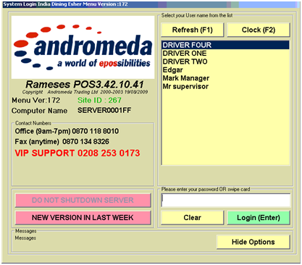

Login to Rameses and complete your standard start of day procedures.

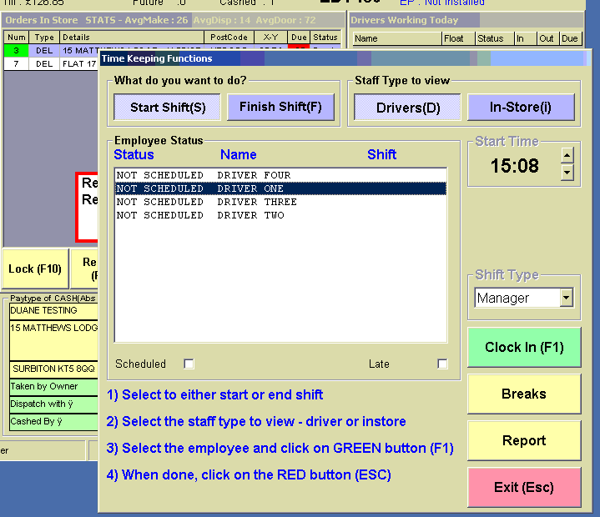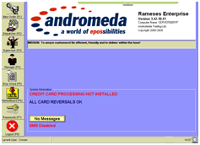

To assign a tracker the driver must be setup within employees, and then use the dispatcher function to clock in the drivers

## Adding a tracker with a driver float

Once a driver has been clocked in press the  button to award the driver a float and a tracker (there is also a separate interface for assigning and un assigning trackers without adding or removing a float).

In the example below Rameses vehicle tracking function has been turned on this is not to be confused with th GPS tracking, the vehicle tracking allows a Rameses user to setup a range of vehicles that are used for delivery purposses and then assign a vehicle to driver allow the user to record the vehicle usage and various other details.

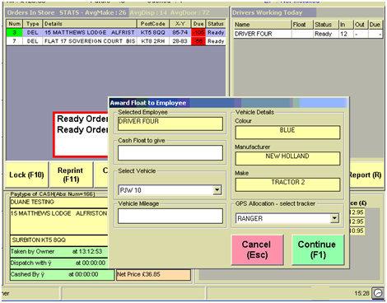

Use this drop down box to view the trackers that are currently synched to the system, once you have selected the desired tracker press  once you have added any driver float amount

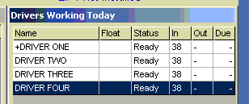

The + symbol before a driver’s name identifies that they have a tracker assigned to them

## Adding tracker to a driver without a float

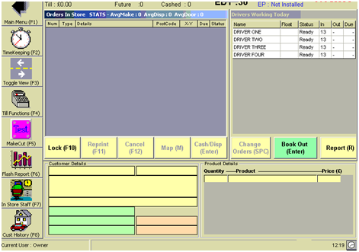

Once drivers have been clocked in, select the driver from the list that you wish to add a tracker

And press the button

Check the status here to see the drivers name and any tracker assigned

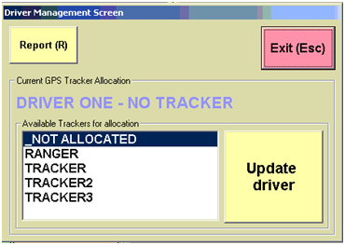

To assign a tracker select an available one from the list and then press the 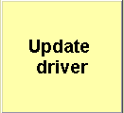 button. The trackers name should be shown on a label attached to the tracker device.

The + symbol before a driver’s name identifies that they have a tracker assigned to them

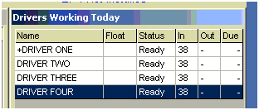

## Remove a tracker from a driver

From the dispatcher screen select the  button

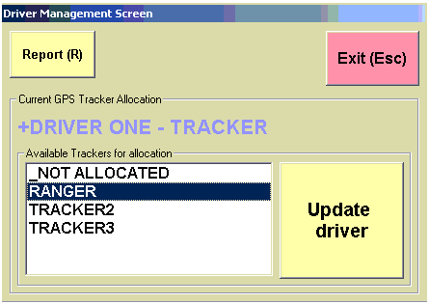

Select not allocated from the list and then press the  button

This process can be used to remove a tracker from a driver that with or without a float.



+ Symbol is removed to show that the driver has no tracker assigned

# The GPS map application

The GPS map application will load automatically when Rameses starts. Once loaded the map automatically centres on the store location and adjusts the zoom to ensure any order locations and drivers are shown.

The map will automatically centre on your store location



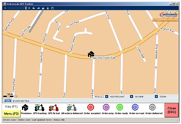

The map key

### The map key

|  |  |
| --- | --- |
|  | This is your store location. |
|  | This is a driver with a tracker assigned. The location of the icon on the map indicates the actual location of the driver to within a few meters. |
|  | This is the last known position of a driver with a tracker assigned. This icon indicates that there is currently a problem communicating with the tracking device. |
|  | This is a driver with a tracker assigned who has been assigned orders and where all the orders have been proximity delivered (proximity delivery is explained later). |
|  | This symbol appears at the customers address location on the map when a customer’s order is first taken. |
|  | This symbol appears at the customers address location on the map when the order status in Rameses is “Oven”. |
|  | This symbol appears at the customers address location on the map when the order status in Rameses is “Ready”. |
|  | This symbol appears at the customers address location on the map when the order has been dispatched from Rameses. |
|  | This symbol appears at the customers address location on the map when the order has been proximity delivered (see later) but not cashed off. |

### 

### The Status Bar

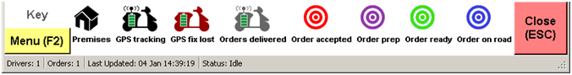

Indicates whether the application is retrieving new map data over the internet or whether there is an error.

The last date/time that the map was successfully updated. The map icons are updated every few seconds over the internet.

The number of orders currently shown on the map

The number of drivers with trackers assigned currently shown on the map

### The Menu



## 

Select here to toggle to the menu

Select here to toggle back to the map key

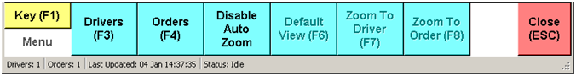

### Drivers Button



Select here to view driver information

A list of ticket numbers currently assigned to the driver

This is the name of the GPS tracking device assigned to the driver in Rameses

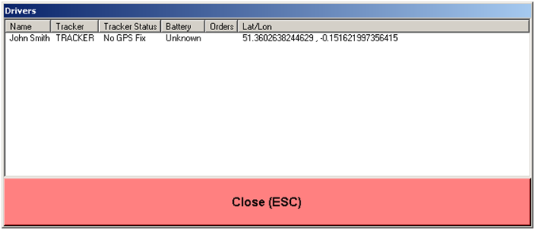

The current % battery level of the drivers GPS tracking device

The current status of the drivers GPS tracking device

The current GPS latitude and longitude of the drivers GPS tracking device

Driver names appear here

#### Tracker Statuses

The tracker status column indicates whether the GPS tracking device is currently receiving radio signals from GPS satellites. The GPS tracking devices use these radio signals to calculate their position. The radio signals generated by GPS tracking satellites are weak. To receive a good signal, a GPS tracking device usually needs to be able to see the sky. When indoors or when not able to see the sky, the GPS tracking device may not be able to receive these radio signals and therefore may not be able to calculate its position. When this happens the Tracker Status will show “No GPS Fix”. The map icon for the driver will change to indicate that it is at the last known position of the GPS tracking device.

“No GPS Fix” will also be shown when the GPS tracking device is unable to send its position back to the central server over the mobile phone network.

### Orders Button



Select here to view order information

The GPS latitude and longitude of customers’ location

The customer’s name appears here

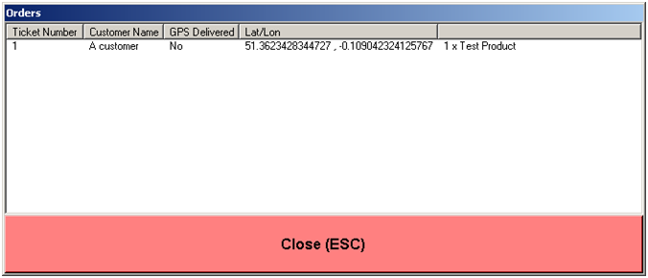

A list of products being delivered to the customer

Indicates whether or not the order has been GPS delivered

Ticket numbers appear here

#### GPS Delivered

When the driver gets close to the customers’ location the system automatically marks the order as “proximity delivered”. The order icon on the map changes colour to indicate that the order has been proximity delivered. If all the drivers orders have been proximity delivered then the drivers icon changes colour to indicate that all orders have been delivered. Note that proximity delivered does not mean that the order is marked as delivered in Rameses. The order must still be cashed off in Rameses when the driver returns to the outlet, at which point it is automatically removed from the map.

### Auto Zoom Toggle Button

The auto zoom feature automatically zooms the map in and out every few seconds to ensure that all drivers and orders are displayed on the map. As drivers and orders appear and disappear from the map, the zoom level is automatically altered. The auto zoom feature can be toggled on and off.



When auto zoom mode is enabled, the manual zoom buttons are disabled

Select here to toggle the auto zoom feature off

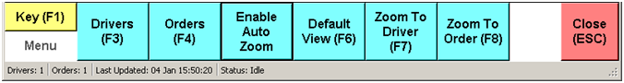

When auto zoom mode is disabled, the manual zoom buttons are enabled

Select here to toggle the auto zoom feature back on

### Default Zoom Button



Select here to reset to the default zoom level

Selecting “Default View” has the same effect as the auto zoom. The zoom level is automatically adjusted to fit all orders and drivers on the screen. Unlike auto zoom, this only occurs once.

### Zoom To Driver Button



Select here zoom in to a specific driver

Selecting “Zoom to Driver” displays a dialog that lists the drivers that have been assigned trackers. When you select a driver from the list, the map is automatically centred on that driver and zoomed in as far as possible.

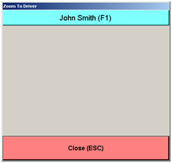

Select here to zoom in to the driver

### Zoom To Order Button



Select here zoom in to a specific order

Selecting “Zoom to Order” displays a dialog that lists all tickets shown on the map. When you select an order from the list, the map is automatically centred on that order and zoomed in as far as possible.

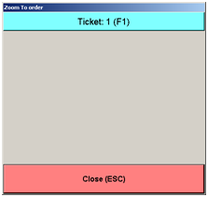

Select here to zoom in to the order

### Controlling the map

Use the controls at the top of the screen to zoom the map.

NOTE the map is designed with an auto zoom feature. Every few seconds the map is automatically centred on the store and the zoom level adjusted to fit all the orders and drivers on the screen. This can be disabled from the menu.

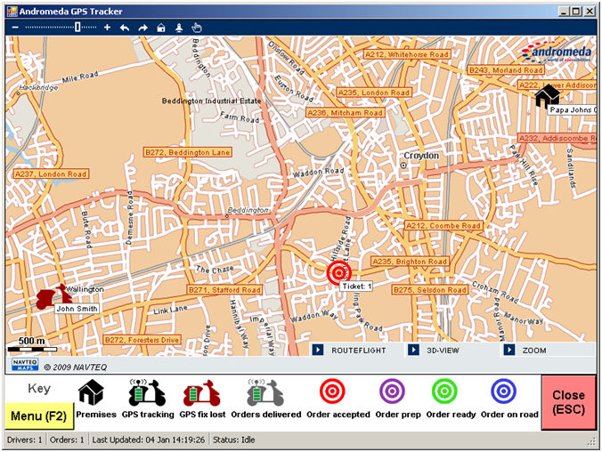

Use this to close the map application

Use this button for a simple 3D view

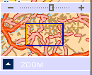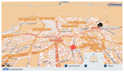

Zoom function shows an overview of map zoom

# Using GPS tracking

To understand how GPS tracking works in an outlet we will step through a typical usage scenario. When Rameses is started, the map shows only the outlet.

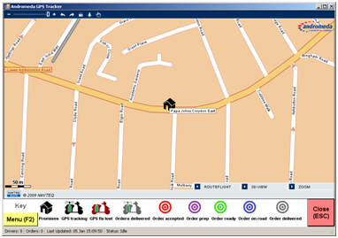

Only the outlet is shown

## Driver start

When a driver starts for the day, the driver takes a GPS tracking device from the charger. The device is assigned to the driver within Rameses using the steps outlined in the Rameses part of the user guide.

The driver appears on the GPS tracking map straight away.

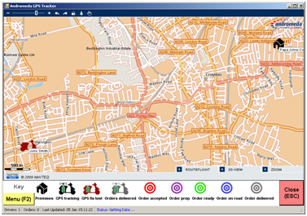

The driver appears on the map. Note that the map automatically zoomed out to show both the outlet and driver

## New order

When a delivery order is placed within Rameses it should appear on the map at the customer location within a few seconds.

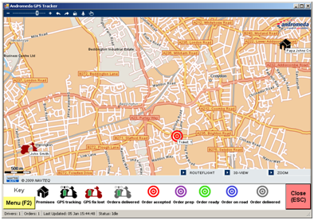

The order appears on the map. The “Order accepted” icon is shown at the customers address

## Order status changes

As the order status is changed within Rameses the colour of the icon should change on the map to reflect the new order status.

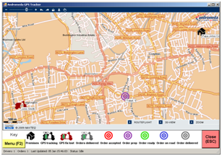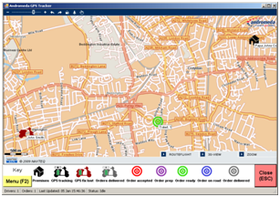

Order icon changes to indicate the order status change in Rameses (ready for delivery)

Order icon changes to indicate the order status change in Rameses (in oven)

## Dispatching an order

When the order is assigned to a driver within Rameses and dispatched for delivery, the order icon on the map will change to reflect this. The ticket number (enclosed in square brackets) is also appended to the drivers name under the driver icon on the map, to indicate that the order is assigned to that driver. If multiple orders are assigned to a driver, a comma delimited list of ticket numbers is shown beside the drivers’ name.

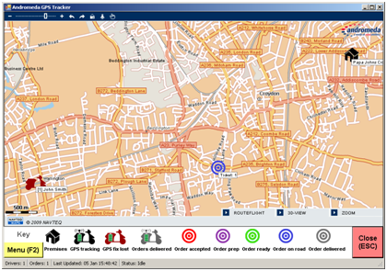 

Order icon changes to indicate that the order is out for delivery

Ticket number is pre-pended to the driver name

## Proximity delivery

When the driver gets physically close to the customer location, the system automatically marks the order as “proximity delivered”. This is not the same as cashing off the order. The order icon on the map will change to reflect this. If all the orders that are assigned to a driver have been proximity delivered then the driver icon will also change to reflect this. This is usually a good indicator that the driver is heading back to the outlet.

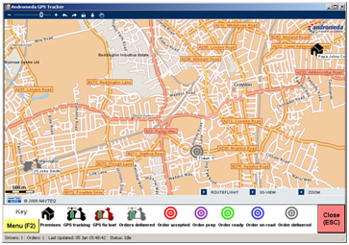

Both order and driver icons change to indicate that the order is proximity delivered

## Cashing off an order

When the driver returns to the outlet and cashes off the orders in Rameses, they are removed from the map. The ticket number/s will be removed from the drivers map icon.



Order icon disappears from map and driver name no longer prefixed with ticket number

## Driver finish

When the driver has finished for the day, the tracker should be removed from the driver in Rameses (see the steps outlined in the Rameses part of the user guide). The driver icon should disappear from the map.

The tracker should be switched off and placed in a charger.



Driver icon disappears from the map

# Troubleshooting and useful information

## GPS Tracking Map

**Outlet icon is in the wrong place on the map**

The position of the outlet map icon is determined by the address in the Rameses settings. Try entering the outlet address on one of the map websites such as Google maps and see if it is shown in the correct location.

**When changing the zoom level or moving around the map the zoom level keeps changing back.**

This is a feature called “Auto Zoom”. Every few seconds the application automatically centres on the outlet and changes the zoom level to fit all orders and drivers on the screen. Auto zoom can be disabled from the menu. Select the “Menu” button at the bottom of the screen and then select “Disable Auto Zoom”.

**Driver is not showing on the map**

When a tracker is assigned to a driver, a map icon should appear almost immediately. There are several reasons why this might happen:

1. A GPS tracker is not assigned to the driver in Rameses.
2. The GPS tracker is unable to receive a signal from the GPS satellites. This can happen if the tracker has been indoors for any amount of time. The tracker may need to see the open sky for a few minutes to get a signal from the GPS satellites before it will appear on the map.
3. The device is switched off. Check that the device is switched on.
4. The device has run out of battery. Check that the battery is charged.
5. Check that the broadband connection is working.

**Order is not showing on the map**

1. Check that GPS is enabled
2. Check that the broadband connection is working.

**Driver is constantly showing as “GPS fix lost” on map**

The “GPS fix lost” icon is displayed on the map when the tracker is not reporting its location. This icon is usually shown when the driver enters an area which does not have a good view of the sky, such as a tunnel or inside a building. The icon should return to normal after a few seconds when the driver returns to an open area. There are three main reasons why the “GPS fix lost” icon is shown:

1. The device is not receiving information from GPS satellites. Check that the device can see the open sky. The blue light on the device will flash every four seconds to indicate that it is trying to get a GPS fix.
2. There is a problem with the GPS tracking device: check that it is switched on and that the battery is charged.
3. The device cannot send its location over the mobile phone network or the data is not being received by the server. The red light on the GPS device will be off or will flash every 8 seconds to indicate that there is a problem connecting to the mobile phone network.

## GPS tracking devices

**GPS tracking device is not charging properly**

Ensure that the device is switched off before putting it in the charger. The device may not charge properly if switched on while charging.

## Rameses

**None of the GPS tracking options are showing in Rameses and drivers are not appearing on the map**

Check that GPS tracking is enabled in Rameses settings.